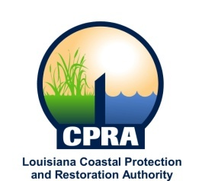

2020 Public Meetings

Chip Chairman of the Coastal Protection and Restoration Authority, and Executive Assistant to Governor Bobby Edwards for Coastal Activities has announced the public meetings schedule for the Coastal Protection and Restoration Authority and the Governor’s Advisory Commission on Coastal Protection, Restoration and Conservation. Details on each meeting will be sent out at a later date. The dates and locations of these meetings are subject to change

CPRA
January 20, 2020
Baton Rouge, LA

February 19, 2020
Plaquemines Parish, LA

March 18, 2020
St. Bernard Parish, LA

April 15, 2020
Baton Rouge, LA

May 20, 2020
Baton Rouge, LA

June 17, 2020
Houma, LA

July 15, 2020
Lulling, LA

August 19, 2020
Baton Rouge, LA

September 16, 2020
Lulling, LA

October 21, 2020
Baton Rouge, LA

December 16, 2020
Baton Rouge, LA

